TABLE OF CONTENTS

- INTRODUCTION (BACKGROUND AND HISTORY)

- OUR MISSION AND VISION

- CORE VALUES

- PROGRAMS INITIATIVES

- TARGET BENEFICIARIES

- GEOGRAPHICAL SCOPE

- PARTNERSHIP AND COLLABORATIONS

- IMPACTS AND ACHIEVEMENTS

- SUCCESS BENCHMARK

- FINANCIAL MANAGEMENT

- GOVERNANCE AND LEADERSHIP

- COMMUNICATION AND OUTREACH

- MONITORING AND EVALUATION

- RESEARCH AND ADVOCACY

- SUSTAINABILITY AND FUTURE PLANS

INTRODUCTION

Background and History
The CATHERINE ADEH FOUNDATION is a non-profit organization that is focused to give hope to the hopeless, the less privileged by restoring human dignity to their lives and most importantly make them feel important in life once again.
The organization was born out of passion to mitigate hopelessness amongst vulnerable groups in Nigeria and across the world. Our services cuts across enhancing quality of education, creating health awareness, advocating for women and children’s right, providing humanitarian services, providing care for the physically challenged and empowering women, youths and children, and mitigating malnutrition among the less privileged, the overall goal of CAF is not to be successful in terms of wealth creation, but to be a success when it comes to giving value to the groups of people they direct their services at or to the cause they choose to pursue.

The organization headquartered in Nigeria, the organization was formed in 2020 and operated as an unregistered organization reaching out to vulnerable groups in every part of the country. However, on 00TH November 2024 the organization expanded its operations as a registered organization with registration CAC/IT/NO 123456 and worked with increased team members to reach out to more individuals in the areas of their core competence.
Our overall goal of CAF is giving value and expressing humanity to vulnerable groups and seeks to advocate through our:

- EDUCATION
- GOOD HEALTH
- EMPOWERMENT
- ADVOCACY

OUR MISSION
To create a sustainable, inclusive world where every individual has access to quality education, essential healthcare, and opportunities for personal and economic empowerment.

VISION STATEMENT
CAF envisions a world where everyone, (regardless of background) has the resources and support needed to lead a healthy and empowered life.

CORE VALUES
- Integrity
- Equity and inclusion
- Empowerment
- Accountability
- Compassion
- Collaboration
- Innovation
- Advocacy for justice

PROGRAMS INITIATIVE
Our programs and initiatives cut across EDUCATION which is fundamental to our mission, CAF works to close educational gaps and below is a list of programs and initiatives.
- CHILD EDUCATION
This is geared towards Child welfare and to ensure the child's safety physically, mentally, emotionally and social health. Stated below are some of the initiatives and approaches for CAF.
- Child Protection and Rights
- Advocacy
- Education and Healthcare
- Protection from Sexual Exploitation and Abuse (consents and rights) (GBV)
- Back to school project
- Scholarship
- Life skills
- Career path
- Foster Care and Adoption Support
- Visitation to internally displaced camps(IDP)/vulnerable communities
- Humanitarian services.
- Psychosocial Support and activies
- Psychosocial support through our healing program (one on one/telepathic children counseling programs).
- Visitation to hospitals.
- Art therapy
- Storytelling
- Yoga and meditation
- Community service

- HEALTH
We strive to ensure that communities have access to essential healthcare services and knowledge by:
- Organizing health camps and clinics that offer free consultations, vaccinations, and essential medicines.
- Conducting health awareness campaigns focused on preventive care, mental health, and maternal and child health.
- Partnering with local healthcare providers to build sustainable community health programs.

- ADVOCACY
CAF believes in advocating for the rights and needs of marginalized communities by:
- Raising awareness about social justice issues, including gender equality, children’s rights, and health equity.
- Working with policymakers and community leaders to influence policies that impact vulnerable populations.
- Hosting community dialogues and workshops that empower individuals to voice their concerns and influence local decision-making.

- EMPOWERMENT
Empowering individuals, especially women and youth, is central to CAF’s mission. Our empowerment efforts include:
- Providing vocational training, business skills workshops, and financial literacy education.
- Offering grants and mentorship to small businesses and entrepreneurs from disadvantaged backgrounds.
- Establishing leadership programs that foster self-confidence and community involvement among youth.

TARGET BENEFICIARIES
CAF target audience focus:
- Vulnerable children
- Vulnerable mothers
- People with disabilities (PWD)
- Aspiring entrepreneurs
- GBV survivors
- Community Health Workers.
- Policy Makers / Local / State/National level.
GEOGRAPHICAL SCOPE
The geographical scope of CATHERINE ADEH FOUNDATION operates at various levels, including local, regional, national, and international

PARTNERSHIPS AND COLLABORATIONS
So far we have partnered with
- Rotary Club
- Nigerian Ministry of Health.
- Nigerian woman affairs commission.
- Nigerian Network of Non-Governmental Organization [NNNGO].
- World Association of Non-Governmental organization [WANGO]
- Family Health International [FHI Nigeria]
- USAID
- Save the Children Nigeria

IMPACTS AND ACHIEVEMENTS
Since its inception, CAF has significantly impacted communities across multiple regions. Key achievements include:
EDUCATION INITIATIVES:
- Provided scholarships and learning materials to over 15,000 students, increasing school retention rates by 20%.
- Built and equipped community learning centers, benefiting more than 5,000 children and adults.
- Implemented teacher training programs in 20 schools, enhancing the quality of education and academic performance.

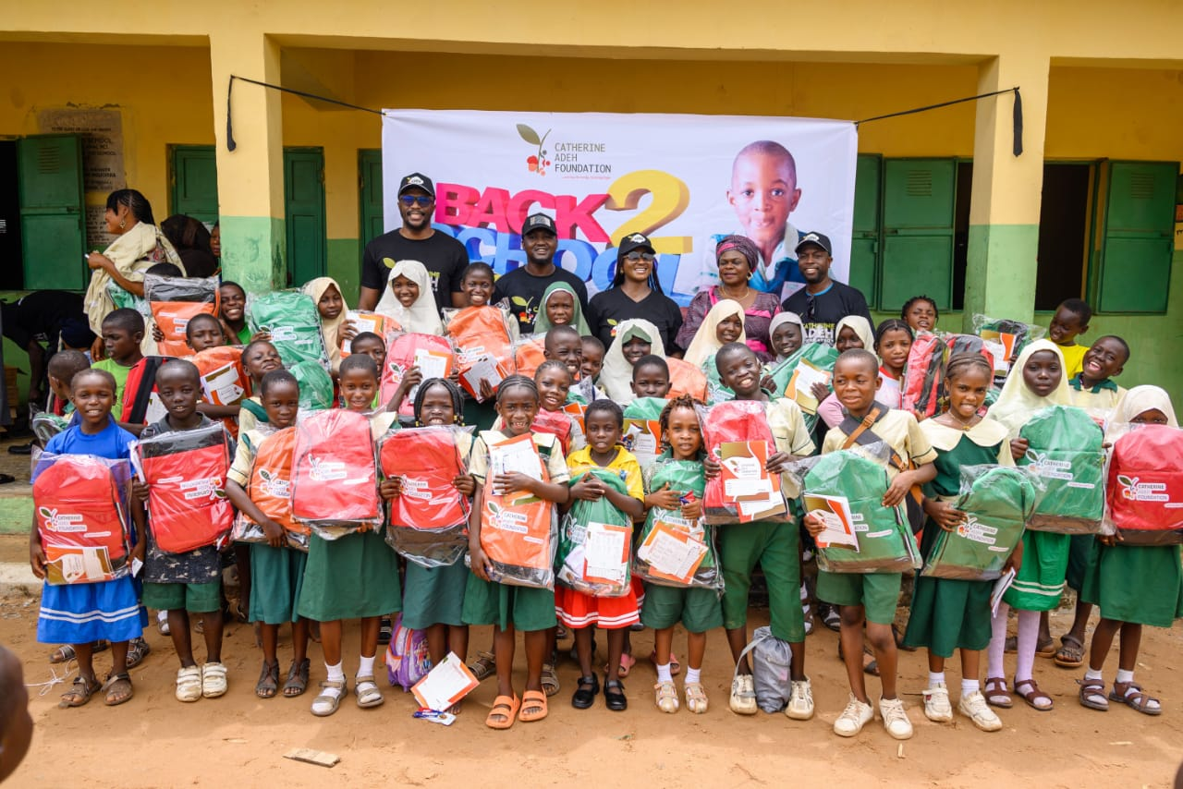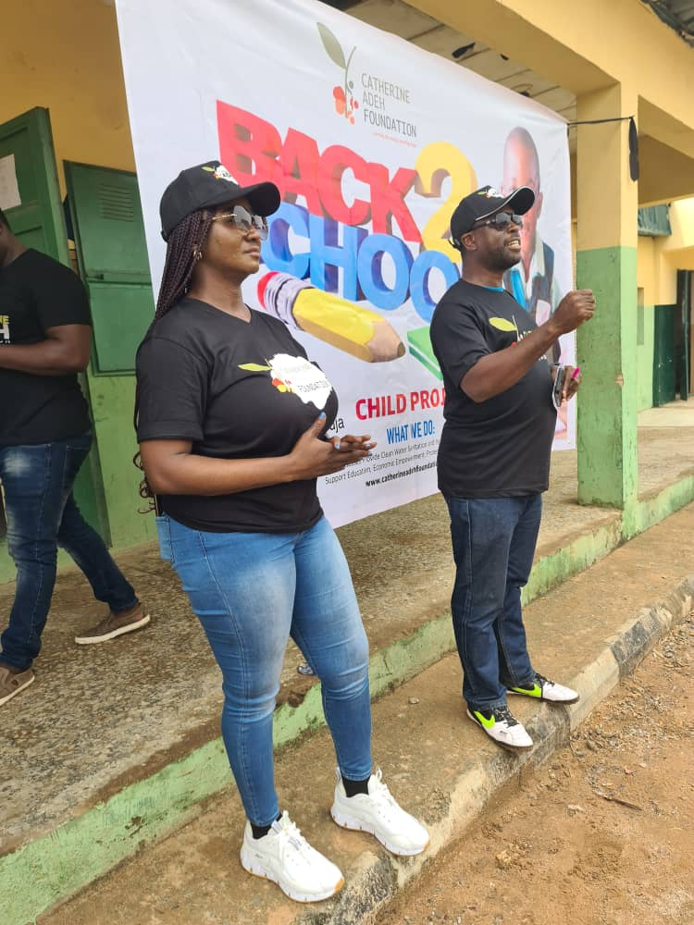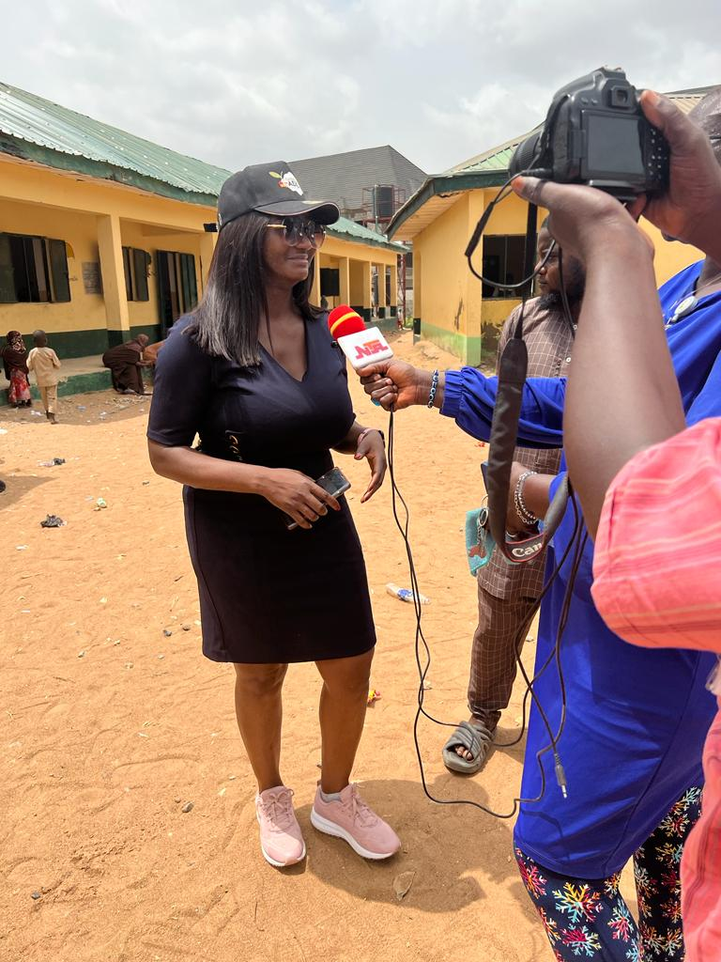

HEALTH PROGRAMS:
- Conducted over 300 health camps and outreach programs, reaching nearly 20,000 individuals with funds for medical bills, screenings, vaccinations, and health education.
- Distributed hygiene kits to over 7,000 families and conducted workshops on hygiene and disease prevention.
- Launched a mental health awareness campaign, offering free counseling and resources, impacting over 3,000 people.

ADVOCACY EFFORTS:
- Successfully lobbied for local policies to support education funding and healthcare access, benefiting numerous communities.
- Held awareness campaigns and workshops for over 8,000 participants, raising awareness about gender equality and child protection.
- Supported community leaders in establishing councils that advocate for marginalized voices and facilitate constructive dialogue with policymakers.

EMPOWERMENT PROJECTS:
  - Trained over 3,000 women in vocational and entrepreneurial skills, with more than half starting their own businesses or gaining employment.
  - Established youth mentorship programs that have inspired over 2,500 young people to pursue education and community leadership roles.
  - Secured micro-grants for 1,000 local entrepreneurs, promoting local business growth and economic resilience.

SUCCESS BENCHMARK
We have been able to identify some of the major causes of poverty in our society and we have perfected our plans on how to reduce these in Nigeria. Although we have outlined actions to be taken in order to achieve our goals, but we are not ruling out the fact that it might be a bit challenging to measure our success rate.
Education and Learning:
- Increase in school enrollment rates for children
- Improvement in educational attainment levels
- Reduction in school dropout rates
- Increase in access to quality education and learning opportunities
- Improvement in literacy and numeracy skills among children
Protection and Safety:
- Reduction in cases of child abuse, neglect, and exploitation
- Increase in child protection services and support
- Improvement in access to legal protection and justice for vulnerable group
- Strengthened child safeguarding policies and practices
- Increase in awareness and understanding of child rights and protection issues
Stakeholder Engagement and Collaboration:
- Strengthened partnerships with government agencies, NGOs, and other stakeholders
- Increased community involvement and participation in program activities
- Enhanced coordination and collaboration among various sectors and actors
- Active engagement of beneficiaries in program design and decision-making processes
Operate a Skill Acquisition
- Empowerment and Development Centre
Professional Counseling
- Mentoring and coaching
- Safe haven

FINANCIAL MANAGEMENT
At CAF our financial management is an ongoing process, requiring regular monitoring, evaluation, and adjustments.
- Budgeting: At CAF, we develop a comprehensive budget that outlines the expected income and expenses for the organization. Allocate sufficient funds for program implementation, administrative costs, staff salaries, and overhead expenses.
- Diversify Funding Sources: we multiple funding sources to reduce reliance on a single donor or grant. Explore avenues such as individual donations, corporate sponsorships, government grants, and fundraising events. Develop partnerships with other organizations and explore collaboration opportunities.
- Grant Management: CAF establishes robust systems for grant management. This includes monitoring compliance with grant requirements, tracking expenditures, and providing accurate and timely financial reports to funders.
- Financial Controls: Implementing strong financial controls to prevent fraud, misuse of funds, and errors. This includes segregating financial duties, conducting regular internal audits, and maintaining proper documentation for all financial transactions.
- Transparency and Accountability: We Maintain transparency in financial operations by regularly reporting financial information to the board of directors, donors, and stakeholders. Publish annual reports and financial statements to provide a clear overview of the organization's financial health.
- Cost Efficiency: we Optimize resource utilization by monitoring expenses closely. Identify areas where cost savings can be made without compromising the quality of programs. Seek partnerships and negotiate favorable terms with suppliers and service providers.
- Cash Flow Management: CAF Manage cash flow effectively to ensure the organization can meet its financial obligations. Maintain adequate cash reserves for operational needs and unforeseen expenses. Consider establishing a cash flow projection system to monitor income and expenses on an ongoing basis.
- Financial Sustainability: At CAF we have developed strategies to ensure the long-term financial sustainability of the organization, this includes building an endowment fund, creating income-generating activities, or exploring social enterprise models.
- Reporting and Compliance: Complying with all legal and regulatory requirements related to financial management is one of our values, filing tax returns, adhering to accounting standards, and meeting reporting obligations for grant funding.
- Seek Expertise: CAF engages financial professionals, such as accountants or financial consultants, to provide guidance on complex financial matters. They assist with budgeting, financial analysis, and compliance issues.

GOVERNANCE AND LEADERSHIP

Organizational structure
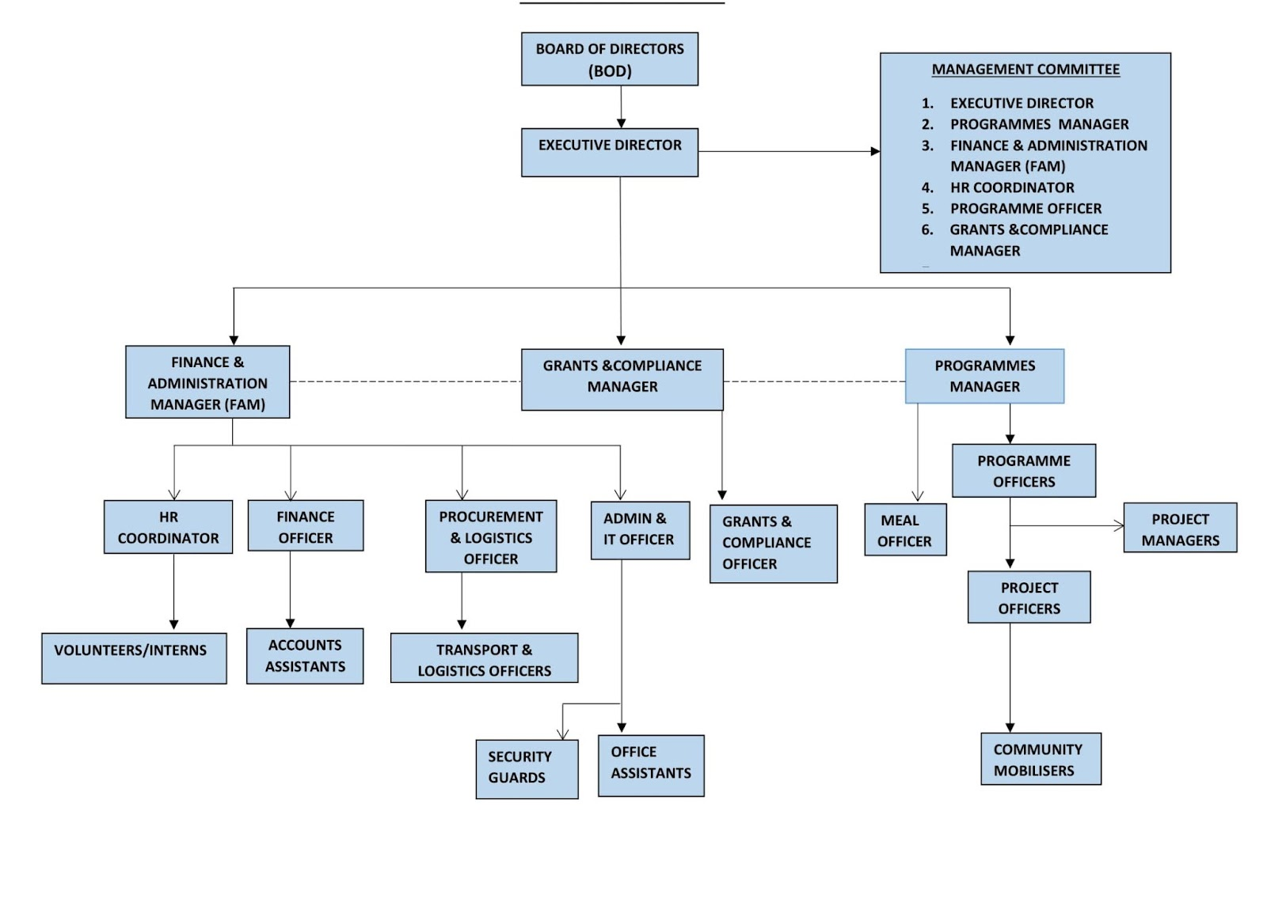

COMMUNICATION AND OUTREACH
Effective communication and outreach is essential for CAF and here are some strategies to enhance our communication and outreach efforts:
- Targeted Messaging: At CAF we tailor messages to specific audiences, such as parents, caregivers, donors, and the general public. Develop clear and concise messaging that highlights the impact of our programs and the importance of education, health, and empowerment.
- Multi-Channel Approach: We utilize a variety of communication channels to reach different segments of our target audience. This may include social media platforms, websites, email newsletters, press releases, and traditional media outlets. CAF also chooses channels that align with our audience's preferences and ensure consistent branding across all platforms.
- Storytelling: Sharing compelling stories that illustrate the impact of our programs on the lives of vulnerable groups. Using personal narratives and case studies to create emotional connections and engage our audience. we also use testimonials and success stories to highlight the positive outcomes achieved through our CAF work.
- Partnerships and Collaboration: Collaborating with other organizations, community leaders, and influencers to amplify our message and extend our reach. Seeking partnerships with schools, healthcare providers, government agencies, CSOs and relevant community organizations. Joint campaigns, events, and initiatives that increase our visibility and credibility.
- Advocacy and Public Awareness: Raising awareness about our programs through advocacy efforts. Engage in public discussions, participate in conferences and seminars, and contribute to relevant policy debates. Position CAF as a trusted authority and advocate for positive change in these areas.
- Engage with the Community: Foster meaningful engagement with our target community is our priority. Conduct workshops, training sessions, and awareness campaigns at schools, hospitals, IDP, community centers, and other relevant venues. Encourage participation, feedback, and dialogue to create a sense of ownership and involvement among community members.
- Volunteer and Ambassador Programs: Recruit volunteers and ambassadors who are passionate about our cause. These individuals can help spread the word about our programs, participate in events, and engage with the community on our behalf. Provide them with training and resources to effectively represent our organization.
- Digital Presence: Developing a strong online presence through a well-designed website and active social media profiles. Regularly update these platforms with engaging content, including informative articles, videos, info graphics, and success stories. Encourage audience interaction, respond to comments and messages promptly, and utilize targeted advertising to reach a wider audience.
- Evaluation and Feedback: Continuously evaluating the effectiveness of CAF communication and outreach efforts. CAF collects feedback from stakeholders, donors, and program participants to understand their perceptions and needs and we use this feedback to refine our messaging and improve our outreach strategies.
- Measurement of Impact: At CAF we regularly measure and communicate the impact of our programs through sharing success stories, statistics, and outcome measurements.

MONITORING AND EVALUATION
Its crucial CAF measures its programs to ensure effectiveness, efficiency, and impact of these programs.
- Program Monitoring: CAF develops and implements its monitoring systems to track the progress and performance of our programs. This includes designing data collection tools, establishing indicators, and setting up processes for regular data collection.
- Data Collection and Management: Coordination and the collection of quantitative and qualitative data is our core and ensures data integrity, accuracy, and confidentiality. Manage databases and systems for storing, analyzing, and reporting program data.
- Evaluation Frameworks: Designing and implementing evaluation frameworks to assess the outcomes and impacts of our programs and develop evaluation plans, methodologies, tools and conducting impact assessments, baseline studies, and end-line evaluations.
- Data Analysis and Reporting: Analyzing program data using statistical and qualitative analysis techniques. Generating reports and dashboards that present findings, trends, and recommendations to inform program improvements and decision-making. Preparing concise and clear summaries of M&E results for internal and external stakeholders.
- Performance Monitoring: The performance monitoring system is a means by which CAF increases its efficiency against established targets, benchmarks, indicators and that of its employees. The purpose of the system is for CAF to fulfill its mission by attaining its objectives and for employees to grow and feel fulfilled through proactive performance supervision.
- Quality Assurance: Ensuring the quality and reliability of program data and information, we develop and implement quality assurance mechanisms and protocols for data collection, management, and reporting, lastly conducting data audits and validation exercises.
- Capacity Building: Providing training and capacity-building support to program staff and partners on M&E principles, tools, and techniques as to promote a culture of learning and evidence-based decision-making within CAF.
- Learning and Knowledge Management: Facilitating the documentation and dissemination of lessons learned, best practices, and success stories from our programs. We Promote knowledge sharing and continuous improvement within CAF.
- Stakeholder Engagement: Collaboration with program staff, donors, and other stakeholders is of utmost priority as this is to ensure alignment of M&E activities with program objectives and donor requirements. Engaging with external evaluation consultants if necessary to conduct external evaluations.
- Ethical Considerations: Ensuring compliance with ethical principles and standards in M&E activities, particularly working with sensitive data related to our programs and upholding the privacy, confidentiality, and rights of program participants.

RESEARCH AND ADVOCACY
- Research Design and Implementation: Designing and executing research studies and assessments related to our programs, this includes formulating research questions, developing research methodologies, collecting and analyzing data, and producing research reports.
- Data Analysis and Interpretation: Analyzing research data using appropriate quantitative and qualitative analysis techniques. Interpreting findings and drawing meaningful conclusions while presenting research results in a clear and concise manner to inform programmatic and policy decisions.
- Policy Analysis and Development: CAF Stay updated on relevant policies, legislation, and international frameworks related to our programs and conduct policy analysis to identify gaps, challenges, and opportunities as to provide recommendations for policy development and improvement.
- Advocacy Strategy Development: Developing advocacy strategies and action plans to advance the rights and wellbeing of children and families while identifying key stakeholders, allies, and target audiences for advocacy efforts.
- Stakeholder Engagement: Building and maintaining relationships with government agencies, policymakers, NGOs, academic institutions, and other relevant stakeholders and collaborating with external partners to advocate for policy changes, program improvements, and resource mobilization.
- Communications and Campaigns: Developing and disseminating compelling advocacy messages and materials through various channels, including social media, websites, publications, and events. Coordinating advocacy campaigns to raise awareness, mobilize support, and drive action on child welfare, wellbeing, and fertility issues.
- Collaboration with Program Teams: Collaborating with program teams to integrate research findings and advocacy recommendations into program design, implementation, and monitoring. Providing technical input and support to ensure evidence-based approaches and best practices.
- Knowledge Management: Contributing to the organization's knowledge management systems by documenting research findings, advocacy efforts, best practices and sharing lessons learned and promoting organizational learning internally and externally.
- Capacity Building: CAF Provides training and capacity-building support to staff members, partners, and stakeholders on research methods, advocacy strategies, and education. Empowering others to effectively engage in research and advocacy activities.
- Monitoring and Evaluation: Collaborating with the monitoring and evaluation team to develop indicators and tools to track the impact of research and advocacy efforts. Monitoring and evaluating the effectiveness of advocacy interventions and adapt strategies accordingly.

SUSTAINABILITY AND FUTURE PLANS
Ensuring the sustainability and future plans of CAF is crucial for its long-term impact and effectiveness of CAF work.
- Strategic Planning: At CAF we have developed a comprehensive strategic plan that outlines the organization's vision, mission, goals, and objectives for education, health, empowerment and advocacy, identifying key priorities and strategies to address current and emerging challenges in these areas.
- Partnerships and Collaborations: Fostering partnerships and collaborations with government agencies, NGOs, academic institutions, and other stakeholders working in the field of our core thematic areas as to leverage collective expertise, resources, and networks to enhance program impact and sustainability.
- Resource Mobilization: CAF Developed a resource mobilization strategy to secure sustainable funding for the organization's programs, this includes diversifying funding sources, cultivating relationships with donors, writing grant proposals, exploring corporate partnerships, and implementing fundraising campaigns.
- Program Innovation and Adaptation: Continuously monitoring and evaluating the effectiveness and relevance of our programs. Staying informed about emerging research, best practices, and trends in education, health and empowerment, adapt program strategies and approaches based on evidence and changing needs.
- Capacity Building: Investing in the capacity development of our staff and partners involved in our thematic areas. Providing training, mentorship, and professional development opportunities to enhance their skills and knowledge in these areas.
- Advocacy and Policy Influence: Continuing advocating for policies and practices that promote education and good health. Monitoring policy developments and engaging in advocacy efforts to ensure the rights and needs of children and families are prioritized on local, national, and international agendas.
- Monitoring and Evaluation: Maintaining a robust monitoring and evaluation system to track the progress, outcomes, and impact of our programs. Regularly assessing program effectiveness, identifying areas for improvement, and making data-driven decisions to enhance program sustainability.
- Knowledge Sharing and Dissemination: Sharing programmatic insights, best practices, and lessons learned within the organization and with external stakeholders. Publishing research findings, case studies, and success stories to contribute to the broader knowledge base in the field of our thematic areas.
- Continual Learning and Improvement: Fostering a culture of learning, reflection, and improvement within the organization. Encouraging feedback from beneficiaries, staff, and partners to identify areas of success and areas needing further attention. Incorporating learning into program design and decision-making processes.

CONTACTS US
www.caf.ng
caf2024@gmail.com
+2348000000000000
X = @caf
Fb = @caf

